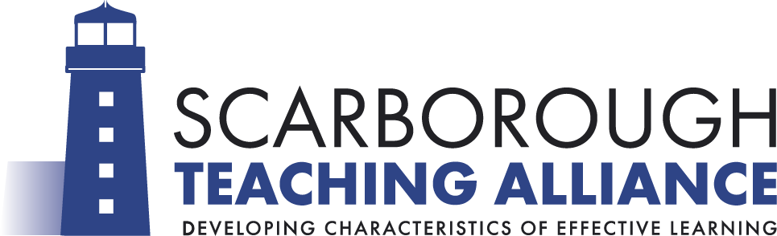
Research and Professional Development Library

FAQs

- How do I borrow a book?

You don’t require a membership card - all you need to do is sign out the book via the form in the green Library folder in the Alliance Training Hub. Please remember to give your school email address so that we can contact you should the book be placed on hold by another colleague.

- How long can I borrow a book for?

The standard loan period is 3 weeks. At this stage, we will email you to check whether you are still using the book. If you are, please let us know and we will extend your loan period unless another colleague has requested access to the text.

- How do I “hold” a book?

The whole catalogue of books available to borrow is on the website - https://www.scarboroughteachingalliance.co.uk/professional-development/library/ as well as a printed copy in the Library folder for reference. If a text is not in the library, please email c.thickett@scalbyschool.org.uk so that we can ask for the return of the book and hold it for you once it has been returned. We will email you when the book is ready to collect from Newby and Scalby Primary School.

- How do I request a book to be purchased for the library?

If you are aware of a useful text that you think colleagues will benefit from, please let us know. Email c.thickett@scalbyschool.org.uk so that the book can be purchased or fill in one of the “request a text” forms from the back of the library folder in the Alliance Training Hub for us to check.

- Will I be fined if I return a book late or lose a book?

We do not charge late fees. However, if a book is lost/damaged we will request reimbursement to cover the cost of a replacement text or we require an acceptable replacement copy of the book that has been lost or damaged.

